Fernando Hernández Cuevas

Age: 57
Marital Status: Married/a
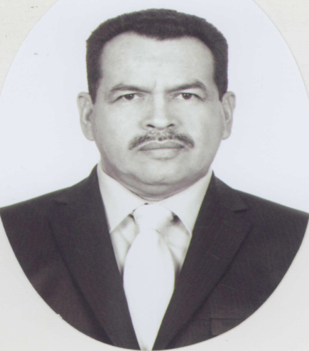
Nationality: Méxican
Home Phone: 3877630292 Mex.
Cel: 3335023723/ 3318393233/ USA Cell phone 408 770 6567
Email: spryaneyjaz@hotmail.com
mx.linkedin.com/in/berrylakefarms
www.hortalizas.com/directorio/berry-lake/
Country: México
Province/City: Jalisco, Jocotepec
Address: Degollado Pte. 76/ 1377 Sunbeam Cir. San Jose Ca.
USA Phone: 1(408) 459-2218- 408 293 2323

Objectives:
Use my 14 years of experience in the production of Raspberries to consolidate
An Exporter that services and provide Worldwide Quality Agricultural Products.

Experience (7)

Sun Basket: Oct. 2016 to present

Quality Assurance: January 2017 to Present
Check quality from Protein and Vegetables we receive from vendors and has to be use in our production, check that bagging lines have the correct items to have it ready for pack, last filter before production goes to customer, check that workers use food safety, quality and GMO, GMP, QA.

General Prep items area Oct. 2016 to Jan 2017
Prepping items to have it ready to bag it and have it ready to be delivery to customer.

Burger King: Jul. 2016/Oct.2016
Receiving Inventory
Receive all goods for store and place it inside our freezer using FIFO system.

2014-2016: Fruit sales from Mexican Small Companies of Blackberries and Strawberry to Whole sellers and Distributors in USA. Also know buyers and Sellers from Salinas, Watsonville, Los Angeles and Orange County and McAllen Tx. And others Countries such as Canada.

General Manager: In: Berry Lake S de PR de RL de CV
August 2013 – Area: General Manager
Personal Area Management, Production, Packaging of Raspberry, Payroll, Application of Pesticides and Fertilizers, Training, Quality control in field , Purchases, Sales , and Accounting Consultants in field , Direction and Management of documentation for Global Gap Certification and Food Safety, Pest Control, Etc.

Founding Partner: SOCIETY INCLUSIVE RIGUFER
2009-2010 General Manager: production of Raspberry, Blackberry and Blueberry

General Manager In: Agrícola Jazmín S de PR de RL
July-2006 a July-2013 - Area: Operation
Personal Area Management, Production, Harvest , Package of Raspberry, Payroll, Application of Pesticides and Fertilizers, Training, Quality Control in field, Direction and Management of documentation for Global Gap Certification and Food Safety, Pest Control, Etc.

General Manager In: Agrícola Yaneyjaz S de PR de RL
December-2002 a June-2006 - Area: General Management / High Address Management
Personal Area Management, Payroll, Production, Harvest, Package of Raspberry, Fertilizer, Application of Pesticides and Fertilizers, Training, Direction and Management of documentation for Global Gap Certification and Food Safety, Pest Control, Etc.

Founding Partner: SOCIETY INCLUSIVE RIGUFER
2009-2010 General Manager: production of Raspberry, Blackberry and Blueberry

General Director , Own Business Hernandez Fruit and Flowers.
July-1991 a May-2003 Area: Commercial / Sales
Production and Sales of Cut Roses under Macro Tunnel grow system, Greenhouse as well as other crops, Bell peppers, Cucumbers, Other Vegetables and Basic Grains.

Quality Control, On: Marlowes Flower
April-1985 a May-1991 - Area: Quality
Quality, Reception and handling, of cut flowers and rotation in Refrigeration Rooms.

General Manager, On: DOMINOS PIZZA
March-1984 a July-1985 - Area: General Management / High Address Management
Accounting, Supervision on the preparation of Pizzas, Personal Management, Monthly and annual Projections, Budget, Training, Help Front Desk Customer, Quality Control, Purchase orders Etc.

Studies (1)
in (U de G)
2007-2012

Languages (1)
English
Intermediate

Additional Knowledge (2)
1979: Agriculture of Maize and Silos
1979: Management and Breeding of livestock dairy
1984: Management flour course, Personnel, Accounting and Sales DOMINOS USA
2003-2008: Handle Pesticides, First Aid, Fertilization, Safety Agriculture Practices , Food Safety
2007: Floriculture Diploma
20012: Agronomic course of Strawberry production in Macro Tunnel.
Fert irrigation and Crop Protected (MACRO TUNEL)
Preparation of Insecticides: From Clove, Thyme, Pepper and Garlic
Hydroponics: Experiment with tillers plants of indeterminate Tomato
Application and Management of Pesticides and Fertilizers and all kind of Agrochemicals in Vegetables crops such as Raspberry, Blackberry, Blueberry and Strawberry.

Basic Hydroponics
Support to Sagarpa and Foundation Produce on Investigation of Production of Strawberry in Macro tunnel Condition, Green House and Open Field with High Elevated conduct and application of Home Made Enzymes with 32 different type of Beneficial Bacteria

More about Me (1)

Passport: Valid Passport
VISA: RESIDENCY VISA
Achieve the goals of the goals of Production and Projection in the Company with I work for it. Achieve goals and exceded when possible and exced the Targets
Ability to travel: Yes
Ride horse and Go outside with Family

References (4)

Eduardo Flores
Ed.flores@lassoit.com
Cell. 650 219 3991
QA Supervisor in Sun Basket

Nicolás Armando Solórzano T
niko.2710@hotmail.com, 3131125924
Proyecto Piña y Compras en Grupo San Carlos

Patricio F. Cortes G.
pcortes@sunbelle.com.mx, 3545410542
Director General en Sunbelle México SA de CV

Ing. Felipe Martínez Casas
fmcasas60@gmail.com, 722244041
Director Ejecutivo Regional en Planesa S.A

Iván Williams
miwmcima@yahoo.com.mx, 3322578078
Gerente de Producción en Hortifrut

NO PROBLEMS FOR TRAVEL ABROAD ( USA )
WITH MORE THAN 20 YEARS OF EXPERIENCE IN AGRICULTURE SECTOR OF PRODUCCTION IN DIFFERENTS
MODES, ( OPEN FIELD, MACRO TUNEL AND GREEN HOUSE ) WITH EXPERIENCE IN
APPLICATIÓN AND RECOMMENDATIÓN OF ALL KINDS OF AGROCHEMICALS AND FERTILIZERS FOR DIFFERENT CROPS.

